20.62: a) As in Example 20.10, the entropy change of the first object is 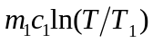 and that of the second is 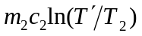, and so the net entropy change is as given. Neglecting heat transfer to the surroundings, which is the given expression. b) Solving the energy-conservation relation for 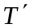and substituting into the expression for 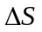gives
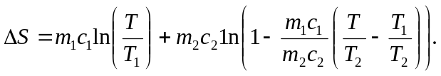
Differentiating with respect to and setting the derivative equal to 0 gives
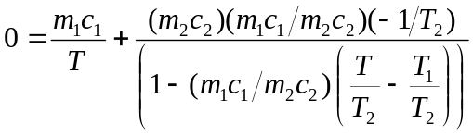.

This may be solved for
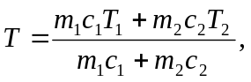
which is the same as when substituted into the expression representing conservation of energy.

Those familiar with Lagrange multipliers can use that technique to obtain the relations
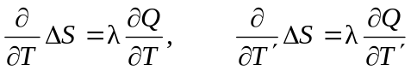
and so conclude that 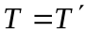 immediately; this is equivalent to treating the differentiation as a related rate problem, as
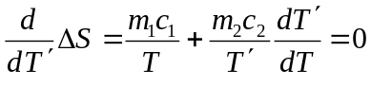
and using 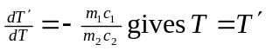 with a great savings of algebra.
c) The final state of the system will be that for which no further entropy change is possible. If 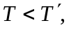 it is possible for the temperatures to approach each other while increasing the total entropy, but when 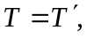 no further spontaneous heat exchange is possible.

